ESTIMATION OF BUSINESS EXPENSES

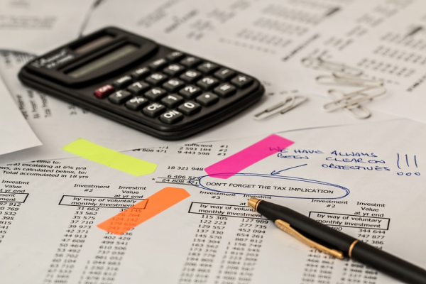

[This Photo](https://technofaq.org/posts/2019/10/4-business-expenses-that-can-be-and-should-be-reduced/) by Unknown Author is licensed under [CC BY-SA-NC](https://creativecommons.org/licenses/by-nc-sa/3.0/)